Deployed Link:

<https://file-syst.herokuapp.com/>

GET request:

/files -> to get all the files in the folder

POST request

/createFile -> create the file in the folder

Create file:

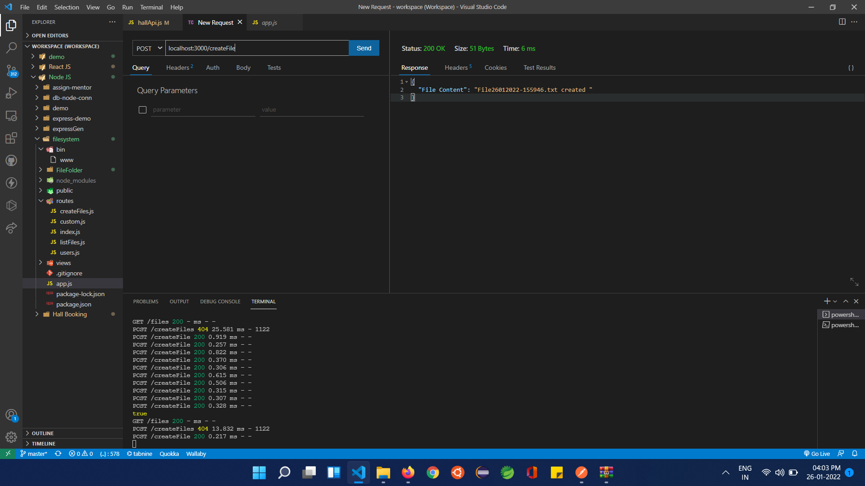

List files:

